Motus

(My Emotion Diary)

By: Ziad Ahmed(T0170536)

Executive summary

Motus is a mood tracker application that features a variety of options to record a person's emotions on a regular basis. This application is meant to aid in the search for patterns in how moods change over time and in response to various events. The name Motus is derived from Latin which mean emotions. Applications that measure people moods can help stop engaging in detrimental habits. According to one study, using a mood tracking app might help teens think less about negatively affecting themselves (Grist et al.2018) and in another research it tells that environments may affect people's moods and mental health, and mental health services are dispersed unevenly across communities (Weir,2017). These two statements shows that mood trackers are helpful but what their lacking their ability to track their moods based on their locations. Motus not only offers mood tracking but also the ability be able to track the users moods based on their location this will aid users in understanding their emotions and also determine why such environments affects their mood.

The main goal of this project is to create an application that will help its users understand their emotions and create coping mechanisms to aid users in dealing with bad moods and undesirable actions.

Usability, Requirements and Guidelines

When comes to designing the application, specific factors must be considered for greatest usability. The first factor is navigation, the application must have consistent and easy to use navigation system. This application will have a bottom tap bar which will allow users to navigate between the different pages in the application and the reason for this is that 49% of individuals use their phones with just one thumb. (TECHINASIA,2016). This navigation bar will also include universal icons as well as what these icons are so that users won’t be confused. The mobile application will offer accessibility for its users so that more people could use the application, this means that the font in the application would have a font size of 12-14 pt(Kogitas,2021) and the combination of these fonts will be used Calibri, Helvetica, Arial, Verdana, and Times New Roman(Siteimprove,2022) as-well as using high contrast in colours . The application will be fast and responsive by compressing any images that will be used in the application, this an important factor as according to Google, 70% of users would quit an app if it takes too long to load(Nowak,2021). The application will also offer simple registration by placing placeholders in the textbox so the user would know what is going on when they are signing in or logging in. To prevent aggravating users with extended wait periods, the application will have on-screen material and transitions should be provided swiftly and smoothly.

When came to the design guidelines, material design was implemented which are guidelines created by google in 2014(Chapman,2022).

The reason for this is that material design is more of a design environment than a collection of style rules. If a prospective design problem occurs, Material design is likely to have a complete set of guidelines about how to manage it. This covers difficult use scenarios that are often ignored by less complete design methods. This may be quite soothing for designers who seek that type of organisation(Chapman,2022).

In this application the colour pallets used was a shade of light green as the primary and light yellow as the secondary. The reason for using a green colour is due to the cool hue that is thought to be relaxing. Cool hues, according to colour psychology, help individuals feel calmer and less nervous. As a result, top name businesses recognised for incorporating the colour green into their colour schemes are typically linked with relaxation, dependability, and high-quality products. Their green tone is meant to inspire relaxation and comfort. They convey the concept of serenity by using various colours of green. (Color Psychology,2021).

Yellow was also used as it is considered a warm hue, which means it can elicit greater emotional responses than cool colours. At the same time, it is a hue that draws attention. In fact, yellow is the most prominent of all colours. Its visibility, as well as its propensity to evoke brightness, warmth, and joy, making it an excellent hue for branding and marketing.

Requirements of this project is done by using the MosCow method

|  |  |  |  |  |
| --- | --- | --- | --- | --- |
| Number | Priority | Requirements | Implications | Task |
| 1 | MUST | User Must be able to login | User can access the Motus | Implement a login functionality |
| 2 | MUST | User Must be able to Sign-up | Users can register in Motus | Implement a sign-up functionality |
| 3 | MUST | User Must be able to Logout | Users can log out when they no longer need the system | Create a functional log-out button |
| 4 | MUST | User Must be able to navigate between the sign-up and login-page | Users will be able to go back if they mis click | Create a go back button |
| 5 | MUST | User Must be able to see their location | Users can see the exact location in the GPS map | Implement GPS functionality |
| 6 | MUST | User Must see their mood on the map when | Users will see the mood they clicked on the map | Implement a functionality that is able to replace the user icon in the map by an emoji |
| 7 | MUST | User Must be able to navigate between different pages | Users can navigate between pages with ease | Implement a navigation system |
| 8 | MUST | Users Must be able to see a calendar and the current mood of the day | When users navigate to the calendar they would be able to see an emoji on the date they are in | Implement a feature that connects the calendar with the moods in the GPS page |
| 9 | MUST | Users Must be able to receive a generated text based on their mood of the day | In the calendar page users would receive a text based on the mood they were in | Implement a feature in which the pre-made text would be appear based on the mood in the calendar |  |  |
| 10 | MUST | Users Must be able to see the number of entries | users will encounter the number of times they clicked each mood | Implement a feature in which the moods are clicked on the GPS page they automatically count in the analytics page |
| 11 | MUST | Users Must be able to see a chart the shows the percentage of entries | User will see their percentage | Use Libraries to generate charts |
| 12 | MUST | Users Must be able to edit their details | Users edit their details including their pictures | Implement an editing functionality |
| 13 | MUST | Users Must be able to choose how many reminders per day | This allows the users to customize their experience | Implement a notification functionality |
| 14 | Could | Users Could see the trail of their movement change based on their emotions | This allows the user to easily document and monitor their moods | Implement a design functionality with some logic |
| 15 | Could | Users Could filter the time duration in which they can the number of mood entries | This allows the user to have more flexibility in the application | Use libraries to customize the filters |
| 16 | Could | Users Could see a mood chart | This allows the user to see more information about their emotions from a different perspective | Use Libraries to generate charts |

.

Constraints & consideration of the wider system

When it comes to implementing this application, constraints are needed to be considered, in regard to how responsive the application will be. The application should be able to run on tablets, phones, and smart watches so that it will be more available to users however realistically since the application will have a feature that can show the user mood based on their location therefore a tablet won’t be needed as most people don’t carry their tablets from a day-to-day basis. Moreover, implementing this application in a smart watch would be ineffective as the screen size is too small to add the core features of the application. Therefore, implementing this application on mobile phones is mostly optimum and mostly the application would be only able to run in portrait mode rather than landscape. One other constraint is to consider is that to function within the limits imposed by the device hardware, mobile devices demand a simplified architecture, simpler UI, and other specialised design considerations therefore this will limit what the final design of the application would be.

One other system constraint is the internet connection as this application is going to use GPS so one of the main features of the application may not work. Moreover, going to places where GPS signal may be weak is another consideration.one other constraint to consider is battery consumption as the application would be using GPS and internet application at the same time. The solution for this is to make the application have pre-loaded maps so the user shouldn’t worry about connection issues

One other major constraint is to consider is the maintenance of databases as there will be a lot of data provided by the users. Moreover, inconsequential data may need to be erased . User information needed to be safely secure and should be easily accessible therefore more maintenance for the database is needed therefore using specific technologies will be costly.

4.Proposed Idea and Impact

**4.1.Proposed Idea**

Motus is a mood tracking application that will allow users from the age of 18 to 45 to track their moods daily. When the user registers to the app the first thing they will encounter is a map with the list of emotions aligned horizontally, the featured emotions that coloured differently that are: happy, rad(awesome ),Meh, desperate and sad . When the user chooses their mood from the list the colour of the mood would register on the map. This will also show on the calendar page and statistics page. In the profile page the user could pick how many reminders they want to receive per day. So, the next time the user inputs a different emotion in the GPS page the application would register that new emotion with the colour of that emotion and the trail that the user made if they are in a new location would change colours from the previous emotion to the next one. The user will also be able to further track their moods by viewing the statistics page which gives them the number of entries per emotion as well as a percentage of the total entries based on different filters. This also supported by a mood chart. The reason for this app is it will allow quick and simplistic methods of tracking users mood without wasting time on making unnecessary and repetitive features like most mood tracking applications.

**4.2.Impact**

This application is categorized as a mental health application and the market for such applications has boomed based on what Harvard Medical School associate professor of psychiatry John Torous said. Moreover, research done by the American Psychological Association stated that mental health applications have existed for as long as the gadgets that provide them, but beginning in 2016, the quantity and popularity of digital tools skyrocketed. There are about 10,000 to 20,000 mental health applications accessible (American Psychological Association,2021). Therefore, this application would increase the profit due to its demand on the market.

5.App features

The app features are determined by the project concept, user needs, personas, and usability. The table below demonstrates the main technical features of the application

|  |  |
| --- | --- |
| Feature | Outcome |
| -Signing up | Allows the user to create an account in the application if they haven’t had one. |
| -Logging-in | Allows the user to log in their account if they created one |
| -Logging-out | This allows the user to logout of the application |
| -GPS system | User will be able to track their mood in |
| -Reminder system | Can allow the user to customize their experience in the app by letting them choose how many reminders they will receive per day |
| -Percentage chart | Will give important information to the user regarding the percentage of emotion they have entered based on the time duration available |
| -Mood chart | Will allow users to see information regarding the emotions they have used throughout a specific time |
| -Calendar system | Will show a calendar to the user and show the last emotion recorder by the user on the dates that the user has used the app on. As-well as the calendar will give a message to the user based on the emotion |
| -A database | To store the user data |
| -A bottom tap bar | Users can navigate the main pages easily in the application without much work |
| -Edit profile | Allows the user to edit their details |

**6.Evaluation of Paper prototype**

Two users have used the prototype created to test its functionality and usability then to see if the design is suitable for this type of application

* User 1

This user particularly enjoyed the design as well as the simplicity of the application, they have stated that they felt the colours pallets were welcoming and was giving them a calm sensation. However, user 1 stated that the emotion icons that are in the GPS page should have names indicating what they represent as they didn’t feel confident when picking how they felt since the emotion icons used where not familiar to them, also the user stated that they couldn’t log-out as there were no logout functionality as-well as a functionality that can let them return to the login/sign-up screen .The user also stated that age should be in the sign-up page . In terms of fonts and their size user 1 stated that they had no issue with the fonts used and was familiar with icons in the tap bar.

* User 2

This user enjoyed the application navigation wise. They stated that they feel the application is familiar and the minimalistic design as well. The user also stated that there is no way for them to edit their profile and less information in the profile page regarding the user . A suggestion was made to make a page to edit the profile of the user. User 2 also stated to add more analysis to the statistics page as one diagram isn’t enough. User 2 stated that there is a lack of consistency with the font colour.

**7.** Appendices

Personas

This diagram below will show the target audience of this application in details

|  |  |
| --- | --- |
| * Michel Angelo * 30 * Lives in New York | **Behavioural demographic information**   * Job: Art Director * Graduated from NYU * Single * Goal: To measure aspects of his life and to improve his mood during work |
| **Requirements (needs)**  Keeps a journal about his life, however he finds it hard to document how he feels throughout the day therefor he can’t determine the cause | **Potential solutions**   * Making him document effectively his mood based of his location. * Supply statistics on his moods based on the time duration he wants * Provide a calendar that would document his mood based the last emotion he picked * Can document his mood up to four times a day |

Prototype before user testing.

In this figure above it shows the prototype of the application before user testing, when the user loads up the application they are welcomed and presented with the option to either sign up or login, if the user selects sign up, they are taken to a page where they input their username, email, and password. If the user clicks on login, they are taken to a page where they input their email, and password . If the user succeeds in signing up /logging up they are taken to the main page which is the GPS page which is represented with a highlighted segment and pin point icon where the user can see their location and click the emotions depending on their mood.

At the bottom of the screen there is a tap bar where the user can use to navigate within the application, the user can navigate in which ever order they desire. The next page is the calendar page which is represented by the calendar in here the user can see data about their moods in terms of specific dates as well as giving them a message depending on their mood that day. The next page is the analytics page which is represented by the statistics icon, here the user can view extensive details about their moods as well as see numerical data about their moods in general. The last page is the user profile page which is represented as an avatar icon here the user can change their photo and customize how many reminders they want per day.

Prototype (Minimal Viable Product) after testing.

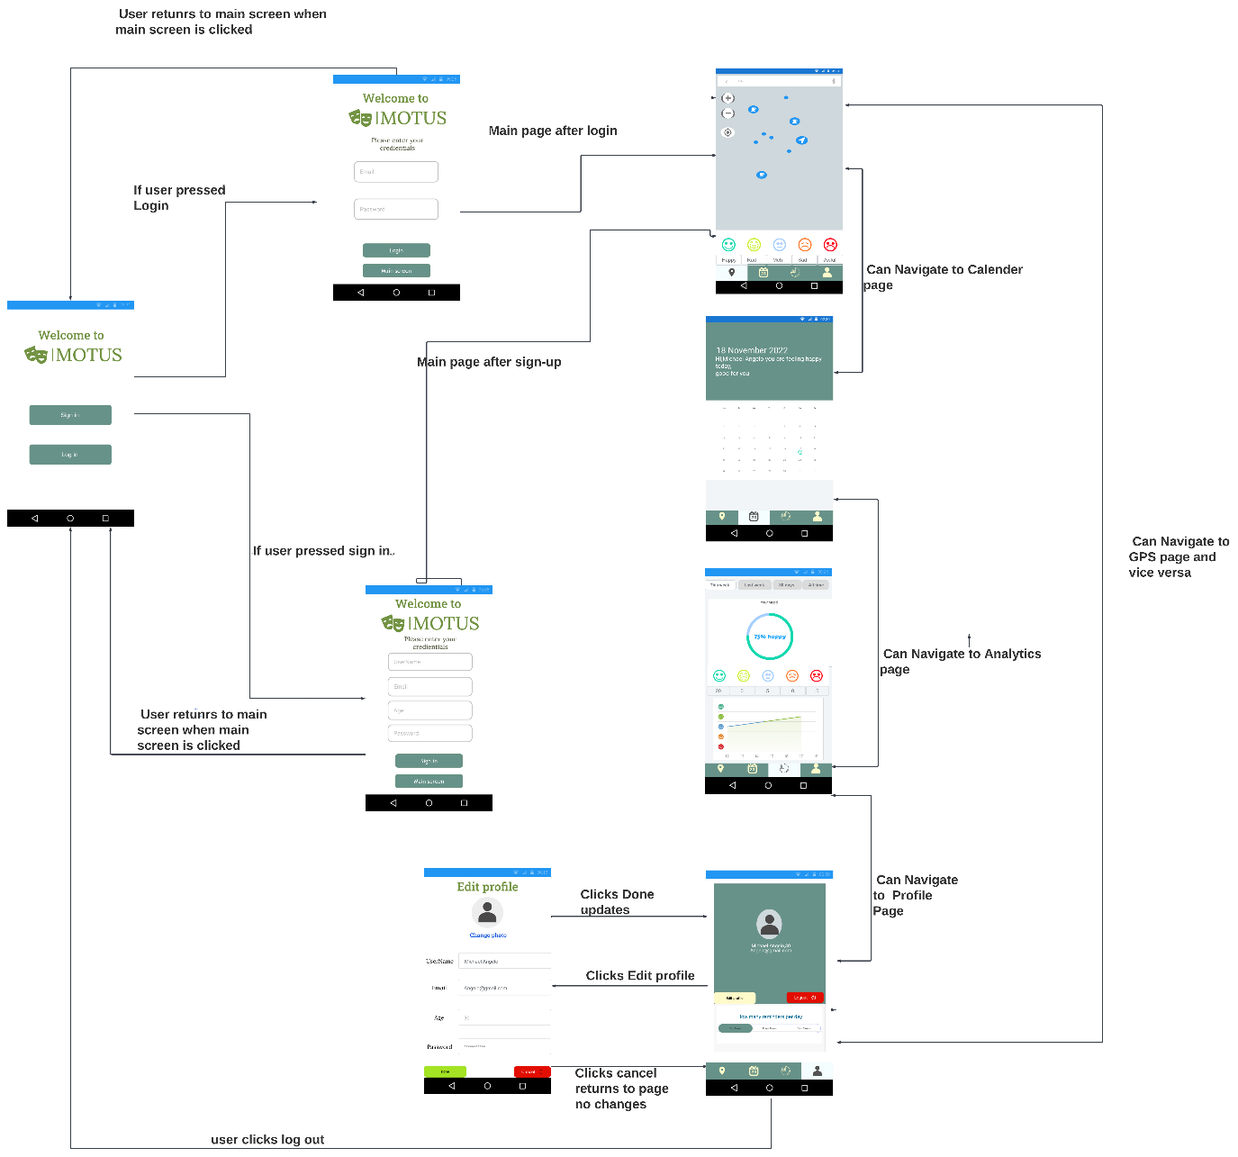

In this figure above shows the updated wireframe after user testing. Like the first wireframe but with a few changes. The GPS page now shows the definition of the emoji icons, the sign-up page now asks for the age. Also, a button called main screen on the login and sign-up page was added to allow the user to go back if they mis tapped. Moreover, the analytics page shows a new diagram called the mood chart which depicts the mood of the user based on their entries, the graph places their entries against the date. Finally, the user page now shows the username, email and age. There is also a logout functionality which will allow the user to log-out returning them to the main screen as well as a edit profile which will allow the user to change their username ,email, age , photo and password. Two buttons are on that page the cancel (red)button goes back to the Profile page with no changes, the Done(green) button updates the changes to the database and goes back to the profile page

REFERENCES

Grist, Rebecca, et al. “Acceptability, Use, and Safety of a Mobile Phone App (BlueIce) for Young People Who Self-Harm: Qualitative Study of Service Users’ Experience.” *JMIR Mental Health*, vol. 5, no. 1, 23 Feb. 2018, p. e16, mental.jmir.org/2018/1/e16/, 10.2196/mental.8779. Accessed 9 Nov. 2022.

Color Psychology. “Green Color Psychology - Green Meaning & Personality.” Color Psychology, 2016, www.colorpsychology.org/green/.

Kogitas. “6 Simple Ways to Make Your App More Accessible to Those with Disabilities.” *Kogitas | Enterprise Mobile Solutions | Oracle E-Business Suite*, 14 Dec. 2021, kogitas.com/blog/6-simple-ways-to-make-your-app-more-accessible-to-those-with-disabilities/.

Nowak, Maja. “Best Practices to Enhance Your Mobile App User Experience.” *Nomtek*, 4 July 2021, www.nomtek.com/blog/how-to-enhance-mobile-app-user-experience. Accessed 12 Nov. 2022.

Siteimprove. “Accessible Fonts: How to Choose a Font for Web Accessibility.” *Siteimprove*, 12 Nov. 2022, www.siteimprove.com/glossary/accessible-fonts/.

TECHINASIA. “Tech in Asia - Connecting Asia’s Startup Ecosystem.” *Www.techinasia.com*, 2016, www.techinasia.com/talk/ux-design-mobile-bottom-navigation.

Weir, Kirsten. “Exploring How Location Affects Mental Health.” *Https://Www.apa.org*, Jan. 2017, www.apa.org/monitor/2017/01/location-health. Accessed 9 Nov. 2022.

American Psychological Association. “Mental Health Apps Are Gaining Traction.” Apa.org, 2021, [www.apa.org/monitor/2021/01/trends-mental-health-apps#:~:text=Mental%20health%2Drelated%20self%2Dhelp](http://www.apa.org/monitor/2021/01/trends-mental-health-apps#:~:text=Mental%20health%2Drelated%20self%2Dhelp).

Chapman, Cameron. “Why Use Material Design? Weighing the Pros and Cons.” *Toptal Design Blog*, 18 Nov. 2022, [www.toptal.com/designers/ui/why-use-material-design](http://www.toptal.com/designers/ui/why-use-material-design).

**Images**

FreePIK. “Free Vector | Buyer Persona Infographics with Photo.” *Freepik*, 18 Nov. 2022, www.freepik.com/free-vector/buyer-persona-infographics-with-photo_9925548.htm#query=persona%20template&position=8&from_view=keyword. Accessed 18 Nov. 2022.